Ex no:1 CLASSES AND OBJECTS
Date:

AIM:
To design as java class which consists of instance variables and methods. Create an object for the class to access all the members of the class and create more than one objects and store the reference of all object in a single variable.

ALGORITHM:
STEP 1: Start the program
STEP 2: Define the Vehicle class blueprint with name, brand, and price attributes.
STEP 3: Create a model() method within the class to print object data.
STEP 4: Initialize the main method in the Car class to start the program.
STEP 5: Instantiate three Vehicle objects and assign specific values to their fields.
STEP 6: Store the created objects into a Vehicle array for collective management.
STEP 7: Iterate through the array using an enhanced for-loop.
STEP 8: Call the model() method for each object during iteration.
STEP 9: Stop the process.
CODING:
class Vehicle
{
String name;
String brand;
int price;
void model()
{
System.out.println ("\n Car:"+name+ "\n Brand: "+brand+ "\n Price:"+price);
}
}
public class Car
{
public static void main (String args[])
{
Vehicle obj1=new Vehicle ();
Vehicle obj2=new Vehicle ();
Vehicle obj3=new Vehicle ();
obj1.name = "Thar";
obj1.brand = "Mahindra";
obj1.price = 1220000;
obj2.name = "Virtus";
obj2.brand = "Volkswagen";
obj2.price = 1800000;
obj3.name = "Verna";
obj3.brand = "Hyundai";
obj3.price = 1900000;
Vehicle [] veh= {obj1, obj2, obj3};
for (Vehicle v: veh){
v.model ();
}
}
OUTPUT:
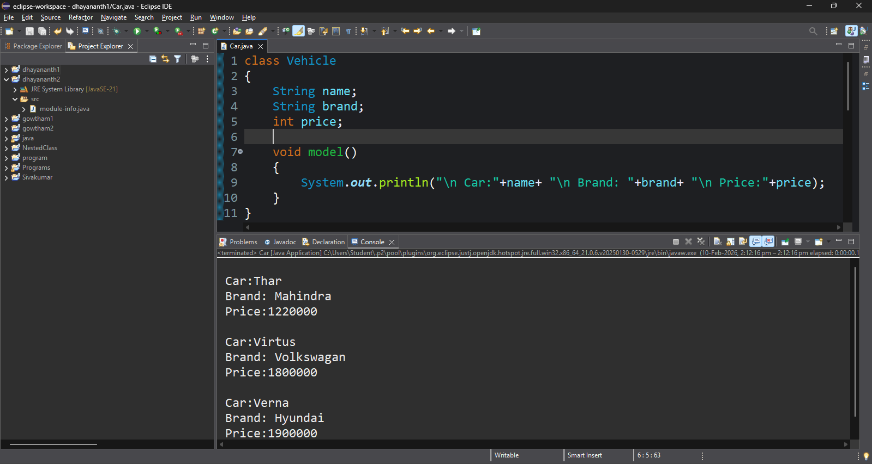
COE(30)
Record(20)
Viva(10)
Total(60)

RESULT:
We have designed a class with instance variables and methods. By creating objects, we accessed all members of the class. Multiple objects were created, and their references were
stored in a single array or collection, demonstrating object handling and reference storage in Java.

